Day 32 – 12th September – 113195064 – Bondili Bhavya Charitha

Task:1 - java -Djava.library.path=./DynamoDBLocal_lib -jar DynamoDBLocal.jar -sharedDb- connected to server.
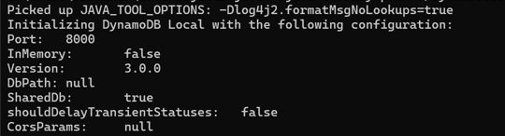
All CRED operations along with dependencies explained by mehar……

Home Task: 1 - Delete a record operation
aws dynamodb delete-item \
--table-name MyTable \
--key '{"id": {"S": "123"}}'

Home Task: 2 – Delete a table
aws dynamodb delete-table \
--table-name MyTable

Home Task:3 – Update a record in a table
aws dynamodb update-item \
--table-name MyTable \
--key '{"id": {"S": "123"}}' \
--update-expression "SET #name = :newName" \
--expression-attribute-names '{"#name": "name"}' \
--expression-attribute-values '{":newName": {"S": "Bhavya"}}'
We can verify these items by giving aws dynamodb scan --table-name MyTable to CLI.
Task:1 – Created a table - done
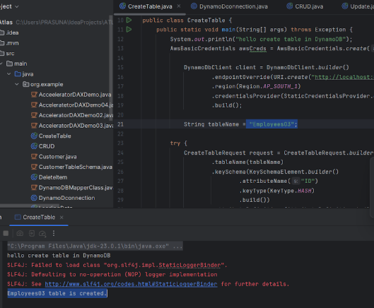
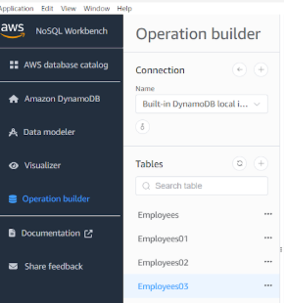

Task:2 – Changing name
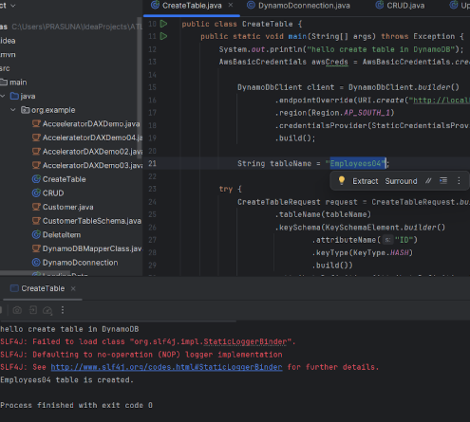
C:\Users\bbhavyac>aws dynamodb list-tables –endpoint-url http://localhost:8000
{
“TableNames”:[
“Employees”
“Employees04”
]
}

Task:3 & 4 –
Loading data to the table
Employee.json
[
{
"ID": 1001,
"Name": "Prasunamba",
"Address": "India"
},
{
"ID": 1002,
"Name": "Meher",
"Address": "Australia"
},
{
"ID": 1003,
"Name": "K",
"Address": "USA"
}
]

package org.example;

import com.fasterxml.jackson.databind.JsonNode;
import com.fasterxml.jackson.databind.ObjectMapper;
import software.amazon.awssdk.auth.credentials.AwsBasicCredentials;
import software.amazon.awssdk.auth.credentials.StaticCredentialsProvider;
import software.amazon.awssdk.regions.Region;
import software.amazon.awssdk.services.dynamodb.DynamoDbClient;
import software.amazon.awssdk.services.dynamodb.model.AttributeValue;
import software.amazon.awssdk.services.dynamodb.model.PutItemRequest;

import java.io.InputStream;
import java.net.URI;
import java.util.HashMap;
import java.util.Iterator;
import java.util.Map;

// loading data to our DynamoDB table
public class LoadingData02 {
public static void main(String[] args) throws Exception {
// using theb Aws credentials
AwsBasicCredentials awsCreds = AwsBasicCredentials.create("fakeaccess", "fakeaccess");

// create a DynamoDb client
DynamoDbClient client = DynamoDbClient.builder()
.endpointOverride(URI.create("http://localhost:8000"))
.region(Region.AP_SOUTH_1)
.credentialsProvider(StaticCredentialsProvider.create(awsCreds))
.build();
System.out.println("connection created successfully");
String tableName = "Employees04";

//object Mapper
ObjectMapper mapper = new ObjectMapper();

//giving input stream of data
InputStream stream = LoadingData02.class.getClassLoader()
.getResourceAsStream(("Employee.json"));
System.out.println("the json file in the input stream");
JsonNode node = mapper.readTree(stream);

Iterator<JsonNode> iterator = node.elements();

while (iterator.hasNext()) {
JsonNode Jsonnode2 = iterator.next();
Map<String, AttributeValue> item = new HashMap<>();
item.put("ID", AttributeValue.builder().n(Jsonnode2.get("ID").asText()).build());
item.put("Name", AttributeValue.builder().s(Jsonnode2.get("Name").asText()).build());
item.put("Address", AttributeValue.builder().s(Jsonnode2.get("Address").asText()).build());

PutItemRequest request = PutItemRequest.builder()
.tableName(tableName)
.item(item)
.build();

client.putItem(request);
System.out.println(" loading the data to the table");
}
client.close();
System.out.println("closing client connection");
}
}
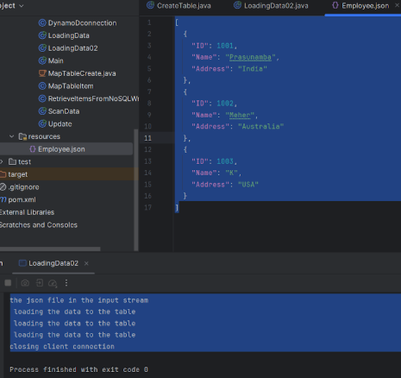

Task:5 - Reading / Scanning/ loading the data from the server. Using java code.
import software.amazon.awssdk.services.dynamodb.DynamoDbClient;
import software.amazon.awssdk.services.dynamodb.model.ScanRequest;
import software.amazon.awssdk.services.dynamodb.model.ScanResponse;

public class ReadEmployees {
public static void main(String[] args) {
DynamoDbClient client = DynamoDbClient.create();

ScanRequest request = ScanRequest.builder()
.tableName("Employees")
.build();

ScanResponse response = client.scan(request);
response.items().forEach(item -> System.out.println(item));
}
}

Task:6 - Insert an item in the NoSQL workbench. And check if the item reflects in your java output.
{
"EmployeeId": "E101",
"Name": "Bhavya",
"Department": "Engineering"
}
ScanRequest request = ScanRequest.builder()
.tableName("Employees")
.build();

ScanResponse response = client.scan(request);
response.items().forEach(item -> {
if (item.get("EmployeeId").s().equals("E101")) {
System.out.println("Found: " + item);
}
});
Task:7 - How do you lower the cost of DynamoDB. explain ways to do so
Below are the practical ways to reduce costs:
- Use On-Demand Mode for unpredictable workloads.
- Enable Auto Scaling to avoid over-provisioning.
- Use DynamoDB Accelerator (DAX) for read-heavy apps to reduce read costs.
- Use Query Instead of Scan to minimize read units.
- Archive Cold Data to S3 or Glacier.
- Avoid Large Items and reduce attribute size.
- Use Global Secondary Indexes (GSI) wisely—they cost extra.

Task:8 - Update item details using java code
import software.amazon.awssdk.services.dynamodb.model.UpdateItemRequest;
import software.amazon.awssdk.services.dynamodb.model.AttributeValue;

Map<String,AttributeValue>key=Map.of("EmployeeId",AttributeValue.builder().s("E101").build());

Map<String, String> names = Map.of("#N", "Name");
Map<String, AttributeValue> values = Map.of(":newName", AttributeValue.builder().s("Bhavya C").build());

UpdateItemRequest updateRequest = UpdateItemRequest.builder()
.tableName("Employees")
.key(key)
.updateExpression("SET #N = :newName")
.expressionAttributeNames(names)
.expressionAttributeValues(values)
.build();

client.updateItem(updateRequest);
System.out.println("Item updated.");

Task:9 - Delete a particular item from the table

import software.amazon.awssdk.services.dynamodb.model.DeleteItemRequest;

Map<String,AttributeValue>keyToDelete=Map.of("EmployeeId",AttributeValue.builder().s("E101").build());

DeleteItemRequest deleteRequest = DeleteItemRequest.builder()
.tableName("Employees")
.key(keyToDelete)
.build();

client.deleteItem(deleteRequest);
System.out.println("Item deleted.");

Creation and Deletion of Cluster is done – Explained by Mehar….

Home Task:1 - What are the features of DynamoDB?
DynamoDB is a fully managed NoSQL database by AWS. It offers high availability, automatic scaling, and low-latency performance. It supports key-value and document data models, provides built-in security, backup, and restore. It also integrates with AWS Lambda, Streams, and DAX for enhanced functionality.

Home Task:2 - What are the advantages and disadvantages of DynamoDB?
- Advantages: Serverless, scalable, fast, and integrates well with AWS services.
- Disadvantages: Limited query flexibility, cost can rise with high throughput, and complex modeling for relational-like data.

Home Task:3 - Where do we use DynamoDB (the uses cases of DynamoDB)?
Used in gaming, IoT, mobile apps, and real-time analytics. Ideal for applications needing fast, predictable performance at scale—like session management, shopping carts, and leaderboards.

Home Task:4 - What is DynamoDB Mapper?
DynamoDB Mapper is a Java-based ORM tool in the AWS SDK. It maps Java objects to DynamoDB tables and handles CRUD operations. It simplifies data access and abstracts away low-level API calls.

Home Task:5 - What are projections in DynamoDB?
Projections define which attributes are copied into indexes. You can project all attributes, only keys, or a custom subset. This helps optimize query performance and reduce storage costs.

Home Task: 6 - How can you say DynamoDB prevents Data loss?
DynamoDB replicates data across multiple Availability Zones. It uses SSD storage and automatic backups. Point-in-time recovery and Streams also help recover or track changes, ensuring durability.

Home Task:7 - What is in-place atomic update means? do you think your DynamoDB supports it?
It means updating an item directly without reading-modifying-writing manually. Yes, DynamoDB supports atomic updates using UpdateItem, ensuring consistency even in concurrent environments.

Home Task:8 - What are Streams in DynamoDB?
Streams capture item-level changes in a table. They allow triggering AWS Lambda functions for real-time processing, replication, auditing, or analytics based on insert/update/delete events.

Home Task:9 - What are DynamoDB Pricing tiers?
Pricing is based on on-demand or provisioned capacity, storage, and optional features like DAX, Streams, and backups. On-demand is pay-per-request; provisioned lets you control throughput.
Home task: 10 - Do you have any max limit for Item Size in DynamoDB? If so, what is it?
Yes, DynamoDB has a limit. The maximum item size is 400 KB, including all attribute names and values.

Home Task: 11 - At a max of how many GSI’s Global Secondary Indexes can you create in a table?
We can create up to 20 Global Secondary Indexes (GSIs) per table. GSIs allow querying on non-primary key attributes.

Home Task: 12 - What is DynamoDB Accelerator?
DAX is an in-memory cache for DynamoDB. It speeds up read-heavy workloads by reducing latency to microseconds. It’s fully managed and compatible with existing DynamoDB APIs.

Home Task: 13 - What are DynamoDB Global tables?
Global Tables replicate data across multiple AWS regions. They provide multi-region, active-active architecture for low-latency access and disaster recovery.

Home Task: 14 - What are indexes and Secondary indexes in DynamoDB?
Indexes let you query efficiently. Primary indexes are built-in (partition/sort key). Secondary indexes (LSI and GSI) allow querying on other attributes without scanning the whole table.

Home Task: 15 - What are Hot Keys and Hot Partitions?
Hot keys are frequently accessed keys that cause uneven traffic. Hot partitions result when traffic concentrates on a few partitions, leading to throttling. Proper key design helps avoid this.

Home Task: 16 - What are Table level operations and Item level operations in DynamoDB?
- Table-level operations include creating, deleting, updating table schema.
- Item-level operations include inserting, updating, deleting, or querying individual records.

